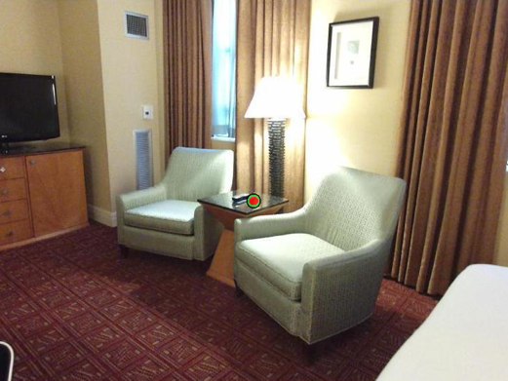

100 ms

time

250, 500, 750, or 1000 ms

500 ms

+

+

+

500 ms